Commercial Filming Procedures
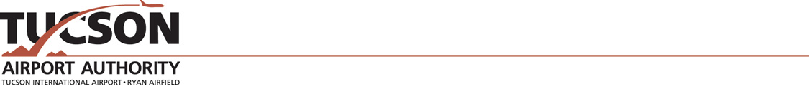

- Request to Film at Tucson international Airport or Ryan Airfield form must be submitted to TAA.

- A Commercial Filming & Photograph License Agreement must be executed with TAA.

- Liability insurance coverage requirements are outlined in paragraph seven of the License Agreement in the amount of $1 million must be confirmed.

- The Authority charges a location fee of $100 per hour, $500 half day, or $1,000 full day and an escort fee of a minimum of $52 per person/per hour based on the needs of the filming request. The Authority will determine the number of escorts required, if any.

- Written approval must be obtained from airport tenants and/or parties involved for use of their facilities and copies provided to TAA. A fee may be charged by the airport tenant for use of their name and/or leased space.

- Written notification must be given to TAA of filming schedule, location and number of people involved in filming, possible hazardous situations, corporate sponsors involved, along with a one-page synopsis of the script and pertinent scenes.

- Producer and Location Coordinator are required to do a walkthrough of the areas to be used with all appropriate TAA personnel and airport tenants involved in order to discuss TAA and/or tenant procedures and requirements. All procedures and requirements must be followed.

- As an informational courtesy to airport passengers, professional signage must be displayed at the site during filming in public areas.

- Filming procedures must not obstruct aircraft operations on the airfield or on the airport roadways and must not interrupt normal operating procedures of the airport. Any activity that impedes the flow of traffic or interrupts the operations of passengers or tenants will not be permitted.

- All operations in secured areas must be escorted by an authorized TAA or tenant employee.

- All persons and equipment must pass through the security checkpoint in order to gain access to the concourse. Gate passes through security checkpoints are provided by an airline. All vehicles entering onto the airfield must have a security check and an escort that will remain with crew and vehicle.

- Security and safety are the airport’s top priority. All airport rules and regulation must be followed. Electrical wires in public traffic areas must be covered or taped down.

- TAA has the right to shut down filming for any reason at any time.

- Applicants should allow two to four weeks to process application depending on project.

